Cut from the Same Cloth: How Two Sacred Relics Can be Used to Save the Church’s grasp on its Worldwide Flock (or not?):
A Comparison of the “Miraculously created” images of
The Virgin of Guadalupe vs. the Shroud of Turin
By Definition:
Just what are Sacred Relics relevant to Catholicism? To begin, let’s start off with the general definition of what a relic is:
Relic: (Latin: “I leave” or “I abandon”) a piece of the body of a saint, an item owned or used by the saint, or an object which has been touched at the tomb of a saint (Wikipedia "Relic").
We recall the notion of a relic from Unit 2—Amiens Cathedral of Professor Bevin’s lecture. In a nutshell, the Catholic Church, since the time of Emperor Constantine and throughout the Middle Ages, use relics to help sanctify a newly constructed church by binding to its altar stone a legitimate and Church sanctified 1st Class Biblical relic. From the Catholic Church’s perspective, there exist three primary criteria to classify a sacred relic (Mangan):
Relic Class | Church Criterion
1st | An actual part of a saint’s body—usually placed in an altar stone*
2nd | A piece of a saint’s clothing or something used by the saint in his actual life
3rd | An object which has been touched to a 1st Class Relic
*Note: If criteria 2 and 3 are both satisfied, then the item automatically becomes a 1st Class Relic (Mangan)

Hypocrisy by the Church? Says Martin Luther, et. al …:
But as the Middle Ages burgeoned into the Renaissance, eventually Martin Luther and the Reformation scholars posited that the Church itself was guilty of hypocrisy itself: violating the 1st commandment of the Decalogue (aka, Ten Commandments in Judeo-Christian teaching):
And God spoke all these words:

“I am the LORD your God, who brought you out of Egypt, out of the land of slavery. You shall have no other gods before me. You shall not make for yourself an idol in the form of anything in heaven above or on the earth beneath or in the waters below. You shall not bow down to them or worship them; for I, the LORD your God, am a jealous God, punishing the children for the sin of the fathers to the third and fourth generation of those who hate me, but showing love to a thousand [generations] of those who love me and keep my commandments” (NIV Bible—Exodus 20: 1-6).

But isn’t the act of honoring a religious item as a Christian Deity a form of idolatry and thus a direct violation of the 1st Commandment, right (Various Protestants ∞)?

In general, idolatry is wrong according to Catholicism:
“Idolatry not only refers to false pagan worship. It remains a constant temptation to faith. Idolatry consists in divinizing what is not God.” (Catechism of the Catholic Church, n. 2113) (Francis)

So, when is idolatry actually a form of divine veneration? Only when a Sacred Relic has the Catholic Church’s explicit written and consecrated “seal of approval”:
In response to Luther and the Reformation, counter-reformation Catholics met at the Council of Trent (16th century) and clarified:
“The holy bodies of the holy martyrs and of the others who dwell with Christ…are to be honored by the faithful” (Mangan; Wikipedia "Relic")

If then, the Church does allow the worship of/with Sacred Relics, when do they seek to promote them? Usually, in a time of need—the need for more religious adherents relative to other competing major world religions and movements (i.e., agnosticism, atheism, secularism, etc.). There are many examples of this trudging out of the Vatican Archive and other areas of unknown Sacred Relics to give the on-the-fence parishioner or non-believer, something tangible to believe in. Here, we shall examine the case in the late 20th Century worldwide in the rule of Pope John Paul II how the Catholic Church fell from grace: being the number one most followed major world religion (in terms as a percentage of the total world population) in 1980 to playing second fiddle to Protestantism by the end of 2010 (Francis X. Rocca):
The Worldview | Latin America
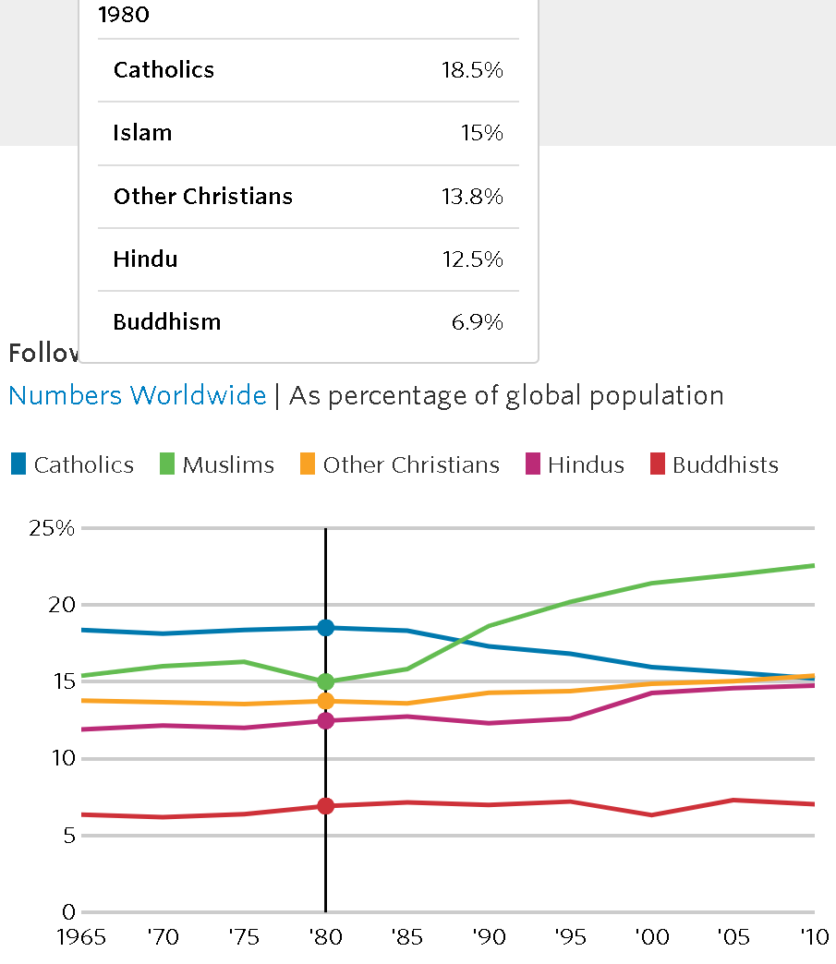 | 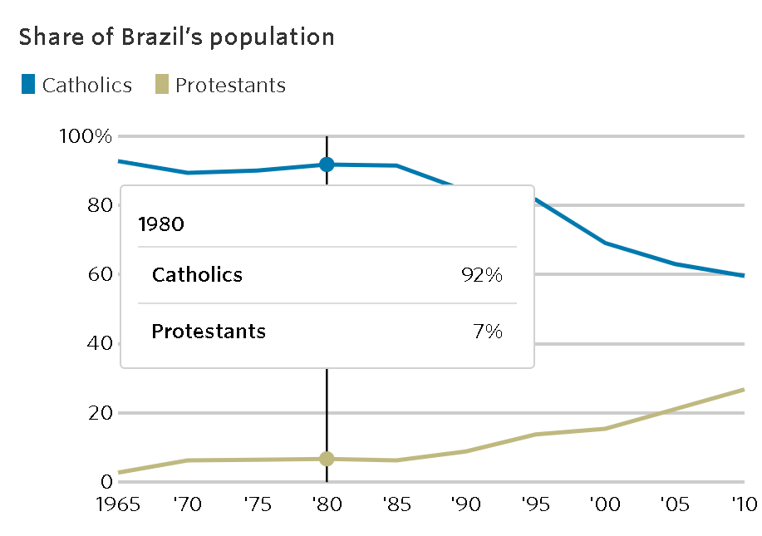
1980: Give me something to believe in, o’ Holy Roman Catholic Church? (WSJ.com)

The Worldview | Latin America
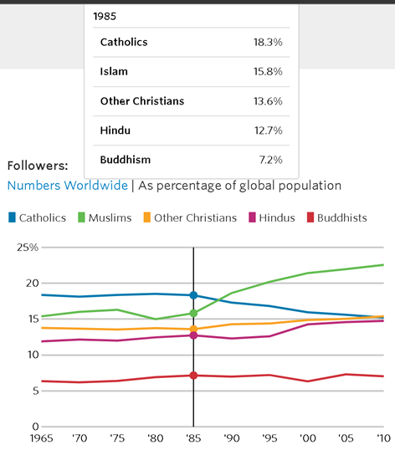 | 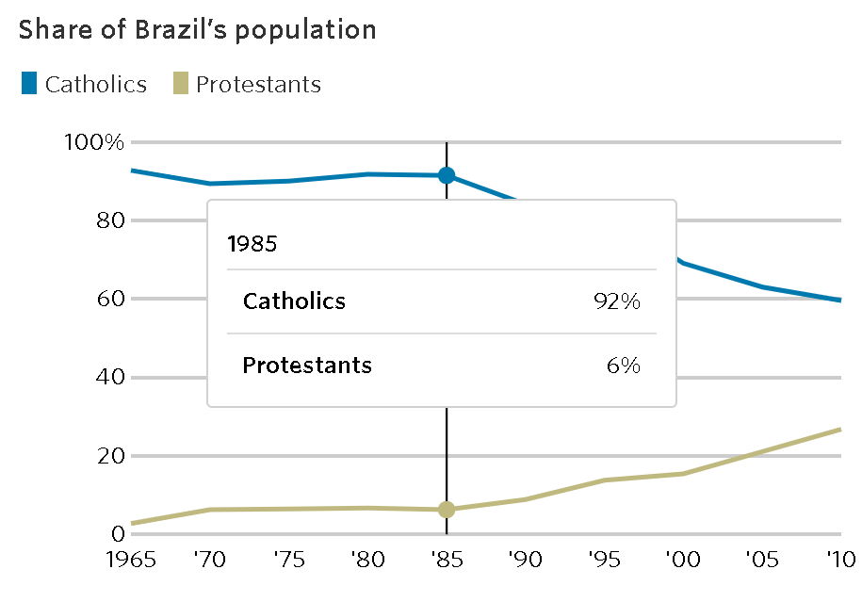
1985: Quick! The Muslims (and Protestants) are coming! Lest not Martin Luther be validated…

The Worldview | Latin America
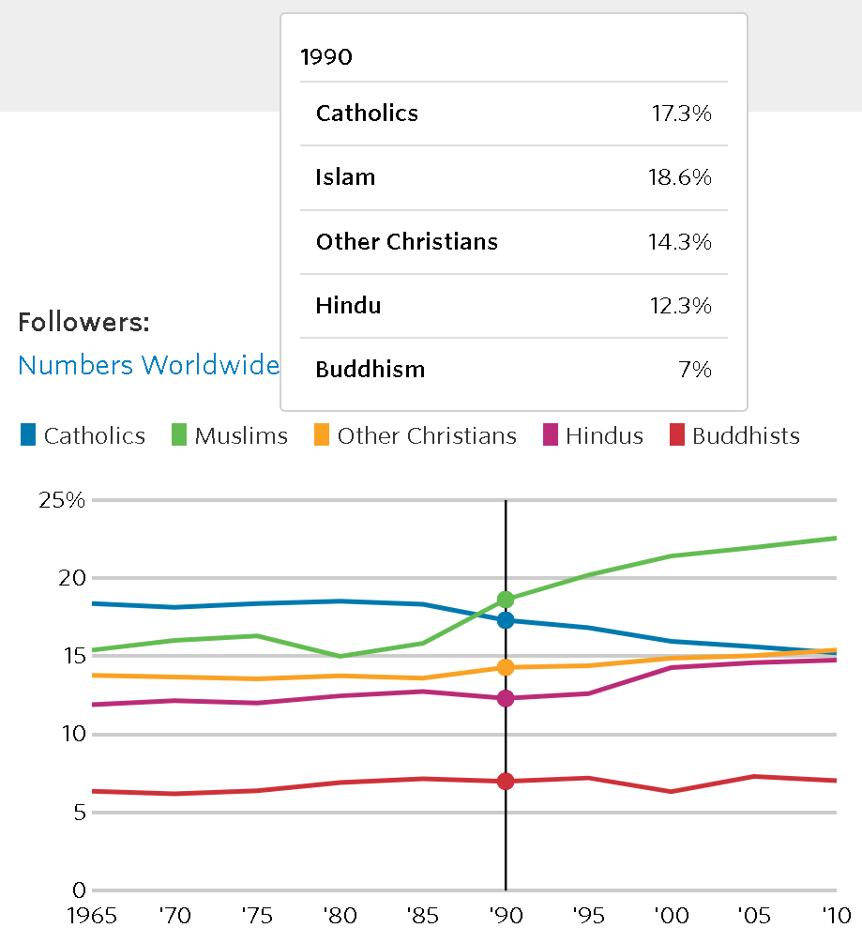 | 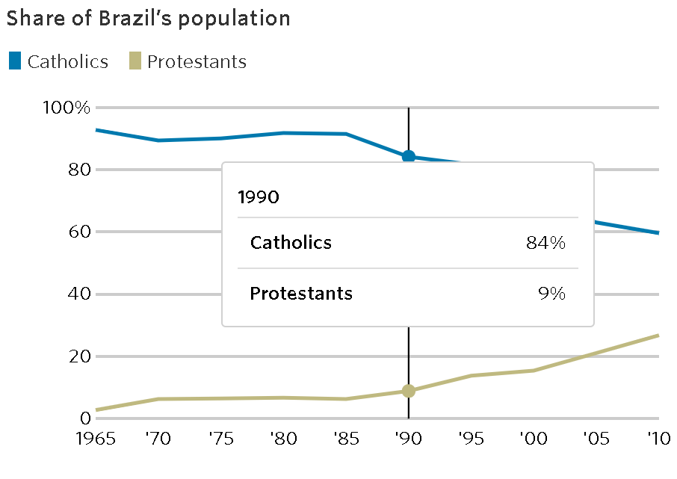
1990: God save the Pontiff! The flock believes Mohammed’s word over ours. Surely, we can still keep Luther’s ex-communicated self under our thumbs?! (Francis X. Rocca)

By 1990, our rockstar Pontiff John Paul II is credited with the destruction of the Berlin Wall and the end of the Evil Empire: The Soviet Union, according to United States President Ronald Regan (Reagan). God and the Church seemed to have prevailed “über alles in der Welt”—but what’s this? Islam has overtaken Catholicism as the World’s largest major religion. Protestantism is becoming more prominent as well…

A Brief Logical Digression (not in official historical record):
Amongst the Pontiff, College of Cardinals, and other Vatican administrative leadership, their minds must have been sent scrambling for a solution! From the Church’s public actions and declarations henceforth, you can see why one can most certainly infer the previous claim in hindsight:
Two hypothetical posits will come to light (via implicitly derived logic) in the media and public record:
- “For our highest growth adherent market, Latin America, let’s promote heavily the sanctity of the Virgin of Guadalupe divine fabric tilma a la screen-print en color and its humble mestizo peasant bearer, Juan Diego!”
- “For Europe and North America, our fastest declining market demographic (especially unto Martin Luther’s Protestants, et. al. …), we shall take complete and total ownership from Italy’s House of Savoy of the famed Shroud of Turin. No longer will it be a secular spectacle but now of divinely christened heritage! It’s now or never—for if we do nothing, we will lose the Flock to Mohammed and Luther by default!”

So, the Church gave Latin America something physical to believe in: the Sacred Relic of the Virgin of Guadalupe and the miraculous appearance of the Virgin Mary unto the mestizo peasant, Juan Diego on a few starry nights in Tepeyac, Mexica. The origin of Juan Diego and the Amazing Technicolor Dreamcoat (aka, The Virgin of Guadalupe Miraculous Screen-print—medium: A “tilma” or modern-day cloth Baja jacket) goes something like this…

Accepted by Historical Record—the Virgin of Guadalupe image on St. Juan Diego’s tilma:
On the first starry night, the Virgin Mary appeared to an indigenous Mexican peasant named Juan Diego on a starry night and told him to get the local Catholic Bishop to build a Church in her honor in the town of Tepeyac, Mexico at once.
The Peasant was not believed by Bishop Juan de Zumarraga. The Bishop demanded physical proof of the peasant’s claim. Juan Diego went back the next night and told the Virgin Mary of the Bishop’s mandate. Mary gave the peasant a bundle of flowers she told the peasant to carry under his “tilma” fabric coat.

The next day, when trying to reach for the divine flowers in his jacket in the presence of the Bishop, they both instead found this “miraculously created” screen-print type image on the inside of the Peasant’s jacket. The Bishop accepted this image as tangible proof of the peasant’s message from the Virgin Mary and commenced the construction of the Church at Tepeyac, per the Virgin Mary’s divine mandate! (Noreen)

Juan Diego’s legend and even pieces of his original tilma jacket were disseminated throughout Latin America and to even Latinos living stateside in the Roman Catholic Archdiocese of Los Angeles. Mere tilma pieces and certified “tilma replicas” were now sanctified as 1st Class Relics by our rockstar pontiff, Pope John Paul II. Real or fantastical, the Virgin of Guadalupe as a 1st class relic and the ancillary origin story of Juan Diego captured the hearts and minds of new Catholic parishioners, formerly indigenous worshipers of other religions or none at all. Now, even in a 1990-day context, a brand new catholic miraculous holy act was now attributed to this resurrected relic of old(Noreen)!

Coincidentally, old habits die hard for the Church. In 1995, the local abbot of the Collegiate Church of Guadalupe, Guillermo Schulenburg Prado, voiced his concerns to the Press about the authenticity of the legend and factual existence of a mestizo peasant named Juan Diego. As soon as Abbot Prado’s interview was televised, his criticism drew heavy public outrage both locally and abroad. How dare he, a man of the cloth, doubt any physical testament to God, let alone justification of the beatification of a future soon-to-be saint (illiterate peasant Juan Diego)? This rhetorical question was ultimately answered en masse via the Abbot (of 22 years) Prado’s forced resignation from the Church—a fate that he and Martin Luther both know all too well (Noreen).

This FDA-like Stage III fast-track approach to Sainthood (championed by Pope John Paul II and Company) continued its blitz to sainthood for Juan Diego. The official beatification certifying body of the Catholic Church, the Congregation of the Cause of the Saints, unanimously recommended Juan Diego for direct canonization (the final step for the nomination of a person to sainthood in Catholicism) in 1998. Many dubious mestizo, Spanish-mestizo, and Spanish language written accounts (of an illiterate peasant!) “miraculously” appeared for the first time in the historical public record to not only certify but to sanctify Juan Diego’s existence and divinity (Noreen).
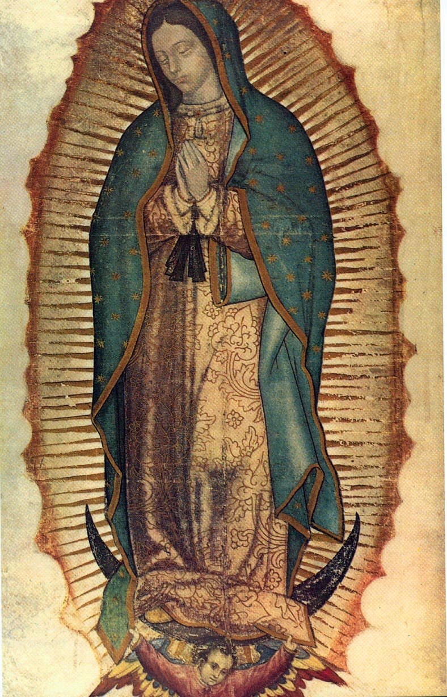
A Mix of the Secular and the Sacred—the Shroud of Turin: a 1st Class Relic of Jesus Christ:
Now for Europe and North America (i.e., amongst English-speaking Catholics), the Church gave everyone their very own “Personal Jesus” incarnate with the official acquisition and sanctification of the Shroud of Turin:

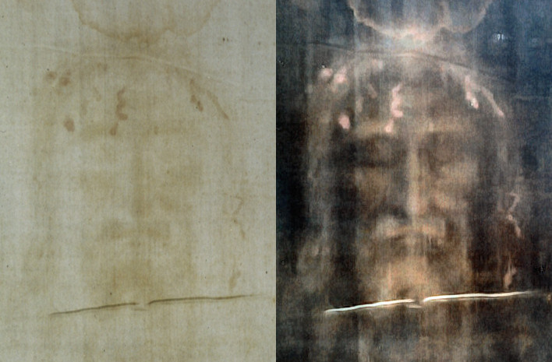

No surprise here folks: The Shroud of Turin becomes widely venerated overnight from its 1988 vilification as a fraud on scientific analysis grounds. Carbon-14 radioactive decay dating with an accelerated mass spectrometer actually cites its date of origin to be of the 14th Century Gothic era (Adler). Also, they cite that the herringbone twill linen weave (from which the Shroud of Turin was woven), was not conceived until the Middle Ages. This weave simply was never observed from other burial cloths of the time of Christ with actual Carbon-14 dating evidence to certify their true authenticity circa 0 AD (Damon et al.).

According to legend, the Shroud of Turin* is the burial cloth Jesus Christ himself was wrapped in upon his entombment. Additionally, upon his miraculous resurrection, he left behind an anatomical autograph of himself or acheiropoieton—a spontaneously-generated image, not made by human hand (Charney). The Shroud of Turin also has healing properties and documented miracles ascribed to it, thus adding a mandylion property to the relic as well (Charney). The medium of this fabric 1st Class Sacred Relic is linen cloth done in herringbone twill weave; negative image imprint: “divine” means—no human technique noted. .

Ever since its first mention in historical records circa 14th century, Church officials have repeatedly refuted its authenticity as a legitimate sacred relic of the Catholic Church (Adler). Being primarily owned and promoted by Secular hands (i.e., the House of Savoy) and not owned or in the official care of the Catholic Church itself, one can see why the Shroud of Turin would be a threat to its canonical authority.

Simply put—the Holy Roman Catholic Church’s founding mandate (aka, covenant) as the intermediary between man and the heavens would be called into question. This New Covenant (covenant: an exchange of persons that is non-terminal; a direct promise from God unto man) formed from both the Old and New Testaments, provides the theological basis and virtual mission statement of the Catholic Church:

God makes three covenants with Abram/Abraham regarding the latter’s descendants: 1) to make of them a great nation (Gen. 15), fulfilled in the founding of Israel by Moses (Ex. 24); 2) to make of them a great kingdom (Gen. 17), initially fulfilled in David and his royal descendants (1 Samuel 16ff.); and 3) to make of them a “catholic” or universal blessing (Gen. 22), i.e., one meant to impact all nations, and ultimately fulfilled in Jesus Christ, the King of kings, who restored and fulfilled the kingdom of Israel in founding the Catholic Church (Luke 1:26-33; Matt. 28:18-20) (Nash).

Brotherhood of the Traveling Shroud: Shroud of Turin Timeline (in brief):

1350s: 1st mention of the Shroud of Turin in Lirey, France. Here, the Lord of Savoy wanted to denote the shroud as a 1st class relic to venerate a church he just built—apparently without official Vatican approval… Recovered by French Crusader Knight Geoffrey de Charny from the Holy Land (i.e., modern-day Israel + Palestine) (Charney).

1389: Pierre d’Arcis, Bishop of Troyes writes to Pope Urban VI demanding the Vatical officially declare the Shroud of Turin a “fake relic” (Charney).
His evidence? D’Arcis cites in his official Papal letter that even his mentor, the former Bishop of Troyes, Henri de Poitiers, concluded the Shroud of Turin was a fraud:

“Eventually, after diligent inquiry and examination [the] said cloth had been cunningly painted, the truth being attested by the artist who had painted it, to wit, that it was a work of human skill and not miraculously wrought or bestowed” (Charney).

1400s-1578: In the semi-private collection of the House of Savoy (ruling monarchy of Italy)—moves to a more public venue in Turin, Italy to attract more religious viewers In 1578.

1958: The Vatican officially recognizes the Shroud of Turin as a true Sacred Relic worthy of Catholic worship. Still owned by the decedents of King Umberto I of the House of Savoy in Italy, even after the fall of Mussolini (Charney).

1983: Upon death, one of the last surviving members of the House of Savoy secular lineage wills over the Shroud of Turin to the Catholic Church and the Archdiocese of Turin (Saunders)
Sub-timeline of the Vatican (particularly Pope John Paull II) allowing for the public discrediting of the Shroud of Turin as a sacred relic, perhaps for the greater glory of God (in Latin: “Ad Marjorem Dei Gloriam”) and historical reasons for the future beatification of Pope John Paul II?
1988: Carbon-14 radioactive decay dating was formally done on a 2” by 3” strip of the Shroud of Turin. Scientists, from three major world universities, publicly declare the Shroud of Turin to be from 1260-1390 AD with a 95% statistical Confidence Interval of
certainty. Mind you, the Catholic Church gave its explicit permission and its blessing for this scientific study to be done (Damon et al.).
June 4th, 1989: Pope John Paull II’s formally endorsed the “Solidarity” movement peacefully ending Communist rule in his home country of Poland. Since 1981, the Soviet Prefect of Poland ruled the country with an “iron fist” under martial law: citizens had to either comply with the dictatorial rule or be shot to death in the street: no matter what (Wikipedia "Pope John Paul Ii").
November 9th, 1989: The Fall of the Berlin Wall—Communist rule ends in East Germany.
December 3rd, 1989: The Soviet Union and the United States of America come to an amicable agreement at the Malta : the Cold War is no more.
December 25th, 1991: Soviet Premier Mikhail Gorbachev officially resigns at the Kremlin and the Soviet flag is lowered for the very last time in history.
April 2nd, 2005: Pope John Paul II dies in Vatican City, Rome, Italy.
May 1st, 2011: Pope John Paul II officially beatified (nominated for sainthood) by Pope Benedict XVI, shortly after death and mandatory waiting period for beatification.
September 30th, 2013: Pope Francis officially canonizes (read: anoints to sainthood) the late Pope John Paul II. The ceremony is held on April 27, 2014 in St. Peter’s Square (Wikipedia "Pope John Paul Ii").

(End of Pope John Paul II’s sub-timeline with respect to the Main Shroud of Turin Timeline)

(Main Shroud of Turin Timeline, continued)

2010: Protestants and Muslims now outnumber Catholics worldwide as a percentage of the world’s total population of religious adherents:
The Worldview | Latin America
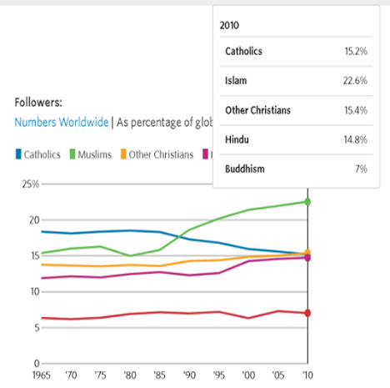 | 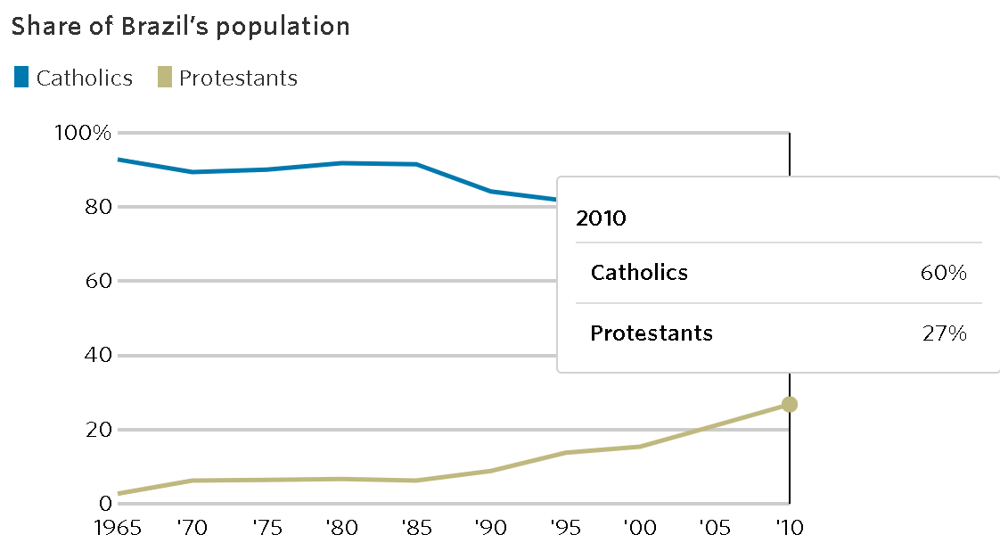

2013: Pope Francis publicly declares the Shroud of Turin as a 1st Class Relic: “[The Shroud of Turin was an] icon of a man scourged and crucified.”
(End of the Main Shroud of Turin Timeline)

A Final Thought:
What was the end result? How well did the ends justify the means for our Jesuit Pope, Jorge Bergoglio*(**)?? The veneration of the Virgin of Guadalupe and the Shroud of Turin probably made the loss of Catholic worshipers worldwide less linear and more logarithmic in decay of overall religious adherents held vs other world religions. So, it did stave off a massive exodus of the 1980 census counted firmly faithful flock (~20% of world population c. 1980). But threats of the “swan song” for the Catholic Church are still very real and they must be better and more clearly addressed if Catholicism is to remain relevant in the 21st Century.

Sadly, by going to such lengths to discredit the Shroud of Turin in previous years (especially since the 1988 Carbon-14 Scientific Analysis refuting the authenticity by age study) on the basis of science instead of faith, the faithful seemed to have flocked elsewhere. Whether or not there is a causal relationship between the Shroud of Turin’s 1988 scientific dismissal of authenticity (Damon et al.) and Catholicism’s loss to Protestantism (in aggregate followers) by 2010 is not entirely certain (Francis X. Rocca), especially with the ulterior motive of guaranteed sainthood suggested by Pope John Paul II’s political movements (aka, pilgrimages) to over 100+ nations during his Papacy (Wikipedia "Pope John Paul Ii")However, I believe Catholic Church’s change of heart over the years certainly did not help the primary reason for venerating a sacred relic: to increase religious adherence amongst the existing flock and non-believing feral sheep alike!
Nota Bene

*NB1: The Catholic Church, prior to 1983, did not have sole rights and ownership of the Shroud of Turin—it was gifted to them by the House of Savoy, the former Italian royal family of King Umberto I (Saunders) .

(**)NB2: Pope Francis is a chemist by Jesuit training.

(***)NB3: Galileo Galilei would have killed to have the “Science Pope” as his ultimate arbiter on his Inquisition tribunal regarding heliocentricity of our solar system!

Errata

British Filmmaker David Rolfe posted a public bounty award of £770,000 (~$1,000,000 USD). He is directly challenging the British Museum to definitively prove its long-held claim that the Shroud of Turin is indeed a “fake relic” (Cailler) Hence, if the British Museum won’t dispute it for a large sum of money, the Shroud of Turin MUST be real. As if Secular veneration of an already venerated Sacred Relic wasn’t enough? But wouldn’t this detract from the divine origin of the Shroud of Turin again? The world may never know (or care to all over again) …

Works Cited
Adler, Alan D. "Updating Recent Studies on the Shroud of Turin." 2002.
Cailler, Adam. "British Museum Offered £770,000 to Prove That the Shroud of Turin Is a Fake." Daily Star Online. Northern and Shell Media Publications https://advance-lexis-com.ezproxy.cul.columbia.edu/api/document?collection=news&id=urn:contentItem:659G-K5N1-DY4H-K4VJ-00000-00&context=1516831. Accessed June 27th 2022.
Charney, Noah. "For Fame or Fortune: Forgery of Archaeological and Palaeontological Artefacts." Authenticity Studies. International Journal of Archaeology and Art, vol. 1, no. Authenticity Studies, Volume 1, Issue 1, 2022, pp. 7-16.
Damon, Paul E et al. "Radiocarbon Dating of the Shroud of Turin." Nature, vol. 337, no. 6208, 1989, pp. 611-15.
Francis, Pope. "Paul Vi Audience Hall, August 1st, 2018 Speech Transcript." 2018. The Vatican of the Holy Roman Catholic Church, https://www.vatican.va/content/francesco/en/audiences/2018/documents/papa-francesco_20180801_udienza-generale.html.
Francis X. Rocca, Yelin Hong and Josh Ulick. "How the Catholic World Is Changing." http://graphics.wsj.com/catholics-world/. 2022.
Mangan, Rev. Charles. "Church Teachings on Relics." Catholic Education Resource Center https://www.catholiceducation.org/en/culture/catholic-contributions/church-teaching-on-relics.html. Accessed June 28th 2022.
Nash, Tom. "Importance of Covenants in the Bible." Catholic Answers https://www.catholic.com/qa/importance-of-covenants-in-the-bible. Accessed July 4th 2022.
Works Cited (cont'd)
Noreen, Kirstin. "The Virgin of Guadalupe, Juan Diego, and the Revival of the<I>Tilma</I>Relic in Los Angeles." Church History, vol. 87, no. 2, 2018, pp. 487-514, doi:10.1017/s0009640718000884.
Reagan, President Ronald. ""Evil Empire Speech" (March 8th, 1983 to the )." 1983. umd.edu, http://voicesofdemocracy.umd.edu/reagan-evil-empire-speech-text/.
Saunders, Father William. "Shroud of Turin--Parts 1 through 4." Shroud of Turin. Catholic Education Research Center web portal https://www.catholiceducation.org/en/culture/catholic-contributions/shroud-of-turin-part-1.html. Accessed July 4th 2022.
Wikipedia. "Pope John Paul Ii." Wikipedia.org, edited by Various Wikis, Wikipedia Foundation, 2022.
---. "Relic." Wikipedia.org, edited by Various Wikis, Wikipedia Foundation, 2022.

